CS 255 System Design Document Template

This template lays out all the different sections that you need to complete for Project Two. Each section has guidance to prompt your thinking. You will need to continually reference the interview transcript as you work to make sure that you are addressing your client’s needs. There is no required length for the final document. Instead the goal is to complete each section based on what your client’s needs are. Remove this note when you are finished, and replace all bracketed text with the relevant information.

UML Diagrams

UML Use Case Diagram
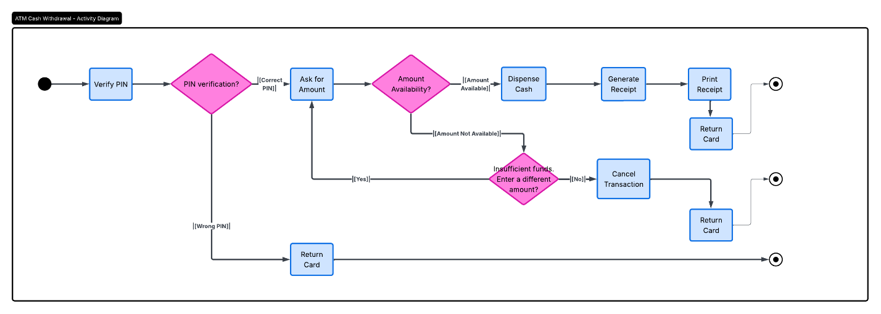

UML Activity Diagrams
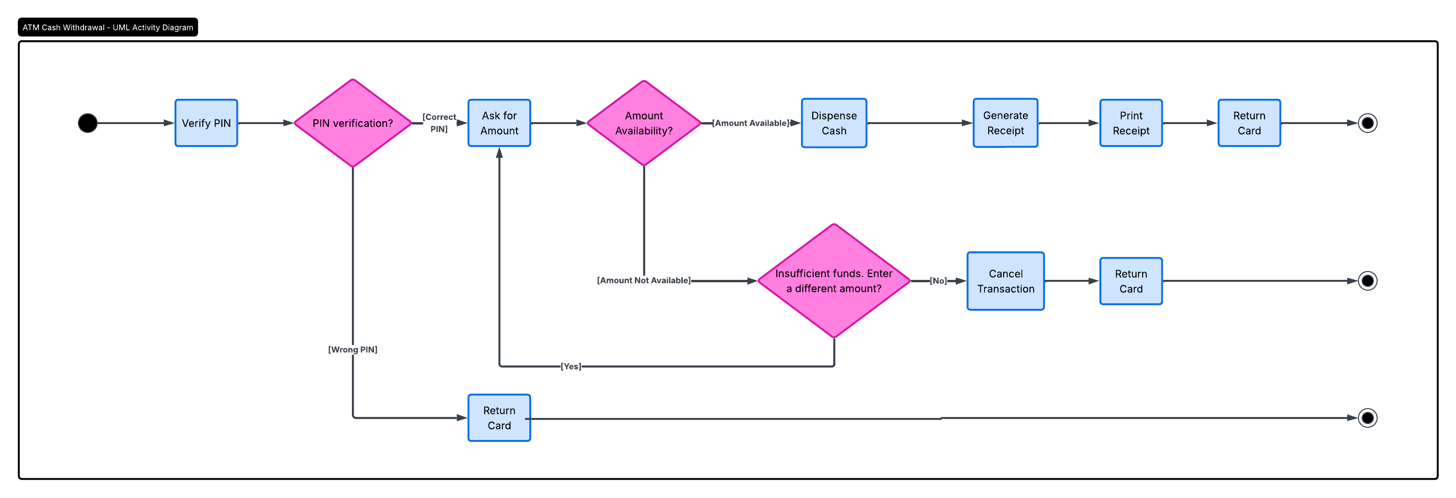

UML Sequence Diagram
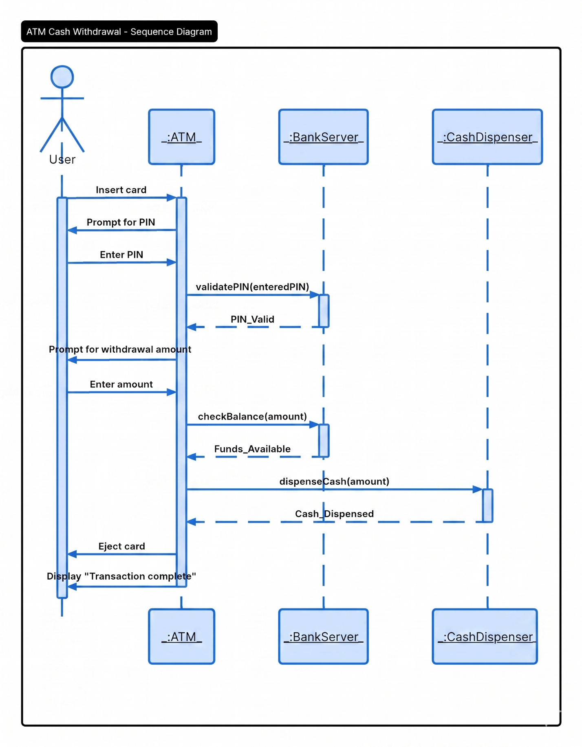

UML Class Diagram
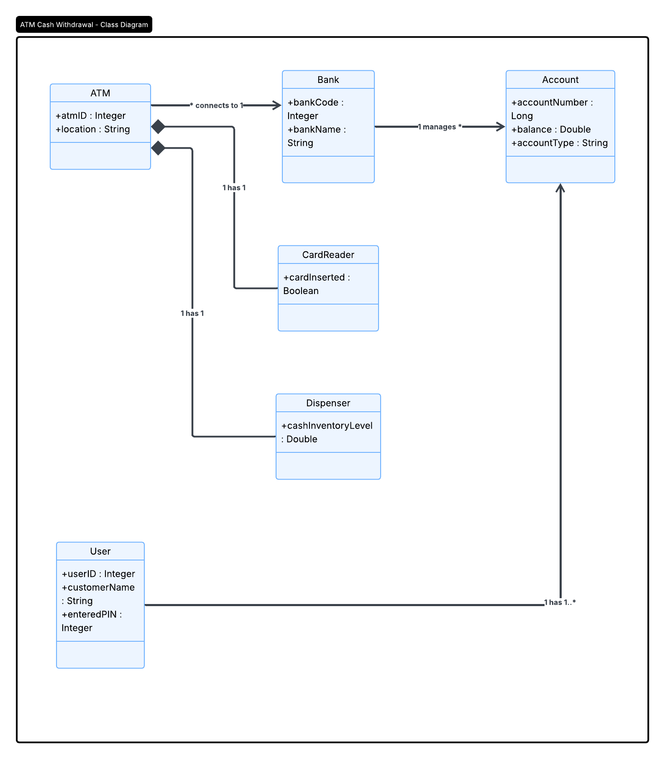

Technical Requirements
System Technical Requirements
1. Hardware Requirements The physical components required to operate the withdrawal system include:
- ATM Terminal: A secure, physical kiosk that houses all local system components.
- Card Reader: A physical peripheral integrated into the ATM to scan user bank cards and initiate the authentication process.
- Cash Dispenser: A mechanical component within the ATM responsible for holding cash inventory and dispensing the authorized amount to the user.
- User Interface Peripherals: A keypad for secure PIN entry and a display monitor to guide the user through the transaction prompts.
- Bank Server Hardware: Remote, high-availability servers configured to process incoming transaction requests and manage database queries in real time.
2. Software Requirements The software architecture needed to facilitate the logic in the sequence and activity diagrams includes:
- ATM Operating System: A secure embedded operating system to run the local ATM application and interface with the hardware drivers.
- ATM Client Application: The localized program that manages the user interface, tracks the state of the transaction, and communicates with the hardware components like the card reader and dispenser.
- Backend Server Application: The central software hosted by the bank that validates the entered PIN, checks the account balance, and authorizes the transaction.
- Database Management System: A relational database hosted on the bank server to securely store user credentials, account balances, and transaction history.
- Security Protocols: End-to-end encryption software to ensure that sensitive data like the PIN and account numbers are protected while traveling between the ATM and the bank server.
3. Tools The tools utilized for the design and potential development of this system include:
- System Modeling: Lucidchart was utilized to design the structural and behavioral UML diagrams representing the system architecture.
- Integrated Development Environment (IDE): Standard development environments like Visual Studio Code or Eclipse for writing and compiling the client and server applications.
- Version Control: Systems like Git to manage code repositories and track application updates.
4. Infrastructure The underlying network and physical facilities supporting the system include:
- Secure Network Connection: A dedicated, encrypted network connection (such as a VPN or leased line) facilitating synchronous communication between the physical ATM and the remote Bank Server.
- Power Redundancy: An uninterruptible power supply (UPS) for the ATM to ensure that a transaction can be safely canceled and the card returned in the event of a sudden power failure.

